**RADx-UP CDCC Data Linkage Guidance**

The National Institutes of Health (NIH) launched the Rapid Acceleration of Diagnostics (RADx) initiative to speed innovation in the development, commercialization, and implementation of technologies for COVID-19 testing. As part of this initiative, NIH developed the RADx-UP (RADx-Underserved Populations) program to understand disparities in COVID-19 morbidity and mortality and to help reduce disparities for underserved populations who are disproportionately affected by the COVID-19 pandemic.

RADx-UP is a community-engaged initiative. Assessing and comparing community level characteristics is essential to the project. NIH strongly encourages collection of identifiers, particularly location-based identifiers like address and zip code, so we can link at an area level using geospatial data linkage. This enables us to look at social determinants of health and understand risk and protective mechanisms for community health. Community-level characteristics can provide insight about populations in specific geographic regions that are particularly vulnerable to COVID-19 infection (e.g., concentration of essential workers) or have resource constraints that might limit access to care for testing/treatment of COVID-19 or other health effects.

There are extensive number of administrative databases that can be accessed to characterize the communities of the RADx-UP participants based on physical address or location. The greatest benefit is achieved when physical address is geocoded at the level of the census tract (small, relatively permanent statistical subdivisions of a county and provide more granularity than a 5 or 9-digit zip code). It is also possible to geocode at the level of zip code or county, but the resulting community measures are less sensitive. One example of an administrative database that can be linked based on address is the American Community Survey (ACS), which helps local officials, community leaders, and businesses understand the changes taking place in their communities. It is the main source for detailed population and housing information about our nation (https://www.census.gov/programs-surveys/acs). Below indices are from the ACS database that were used for linking purposes (using the 5-year 2019 version).

* **The Agency for Healthcare and Quality (AHRQ) Socioeconomic Status (SES) Index**: The AHRQ_SES index is a socioeconomic status metric based on neighborhood housing, education, and income statistics across 7 core variables. A lower SES index values represent a lower socioeconomic status. Below is the information about the 7 core variables their data type and definitions. ACS has bulk of detail tables and the ACS table ID is purposely numbered to describe its content and format. The ID helps to uniquely identify the table to that variable. AHRQ_SC is the calculated variable.

|  |  |  |  |  |
| --- | --- | --- | --- | --- |
| **Attribute/Column Name** | **Attribute/Column Physical Name** | **Physical Data Type** | **Definition/Survey Question** | **ACS Table ID** |
| Zip | Zip | varchar(50) | ZIP code |  |
| NAME | NAME | nvarchar(50) | ZCTA5 + ZIP code |  |
| IBPL | IBPL | nvarchar(50) | Percentage of people below the federally defined poverty line | (B17021) |
| COH | COH | nvarchar(50) | Percentage of households containing one or more person per room | (B25014) |
| LEDU | LEDU | nvarchar(50) | Percentage of people aged 25 years or older with less than 12th grade education | (B15002) |
| HEDU | HEDU | nvarchar(50) | Percentage of people aged 25 years or older with at least 4 years of college | (B15002) |
| PMV | PMV | float | The median value of owner-occupied property values, standardized to range 0 to 100 | (B25077) |
| ULF | ULF | nvarchar(50) | Percentage of people aged 16 years or older in the labor force who are unemployed and actively seeking work | (B23025) |
| MHI | MHI | nvarchar(50) | The Median household income, standardized to range from 0 to 100 | (B19013) |
| AHRQ_SC | AHRQ_SC | float | The Agency for Healthcare Research and Quality (AHRQ) status score | Calculated Variable |

**The link to access the AHRQ index**: <https://citeseerx.ist.psu.edu/viewdoc/download?doi=10.1.1.233.6403&rep=rep1&type=pdf>

**Technical Documentation:** <https://dcri.atlassian.net/wiki/spaces/DBIA/pages/2999222386/rpt+ahrq+ref>

Below is an example of how the table will look like once we append all the ACS variables that are used to calculate the AHRQ_SC variable

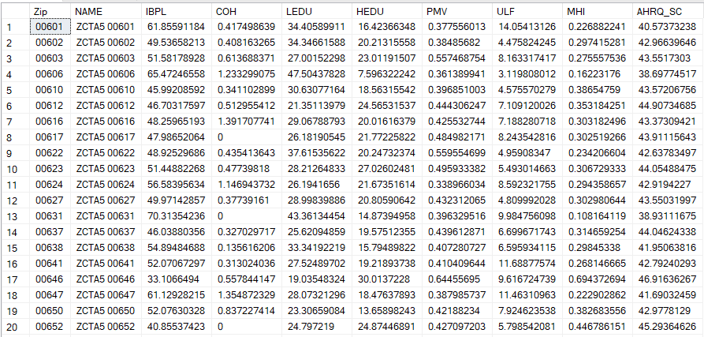

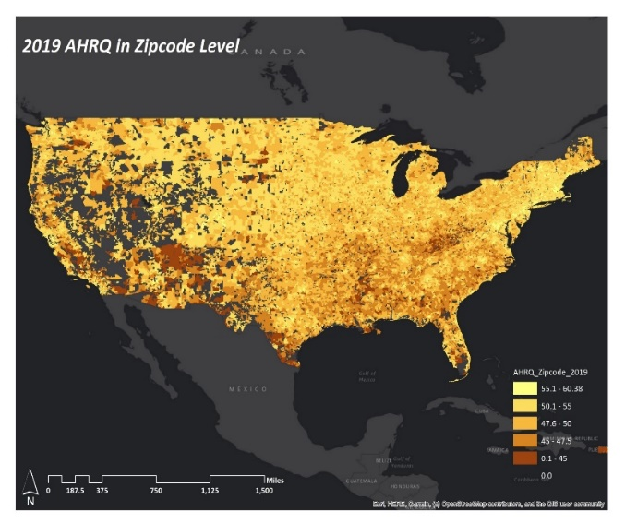

This interactive map provides insight into each of the linked area level datasets above the zip code level across the US.

* **CDC Social Vulnerability Index (SVI)**: The SVI uses US Census data to determine the social vulnerability of every county and tract based on 15 social factors. Higher SVI value represent higher vulnerability. Below is the information about the Themes that are used in this index, their data type and definitions. ACS has bulk of detail tables and the ACS table ID is purposely numbered to describe its content and format. The ID helps to uniquely identify the table to that variable. THEMES_SC are the calculated variable.

|  |  |  |  |  |
| --- | --- | --- | --- | --- |
| **Attribute/Column Name** | **Attribute/Column Physical Name** | **Physical Data Type** | **Definition/Survey Question** | **ACS Table ID** |
| Zip | Zip | Varchar(50) | Zip code |  |
| Name | Name | Nvarchar(50) | ZCTAS + ZIP code |  |
| RPL_THEME1_SC | Socioeconomic Status | nvarchar(50) | below poverty, unemployment, income, no high school diploma | B17001, DP03, B19301, B06009, S0601, DP03, |
| RPL_THEME2_SC | Household composition & disability | nvarchar(50) | aged 65+, aged 17 or under, older than 5 with a disability, and single parent household | S0101, B09001, DP02, SVI |
| RPL_THEME3_SC | Minority Status & Language | nvarchar(50) | minority, speak English “less than well” | B01001H, B16005, SVI |
| RPL_THEME4_SC | Housing Type & transportation | nvarchar(50) | multi-unit structures, mobile homes, crowding, no vehicle, group quarters | DP04, B26001, SVI |
| RPL_THEMES_SC |  | nvarchar(50) |  |  |

**The link to access the SVI index**: <https://www.atsdr.cdc.gov/placeandhealth/svi/index.html>

**Technical Documentation**: <https://dcri.atlassian.net/wiki/spaces/DBIA/pages/2999222439/rpt+svi+ref>

Below is an example of how the table will look like once we append all the ACS variables that are used to calculate the SVI Theme variables

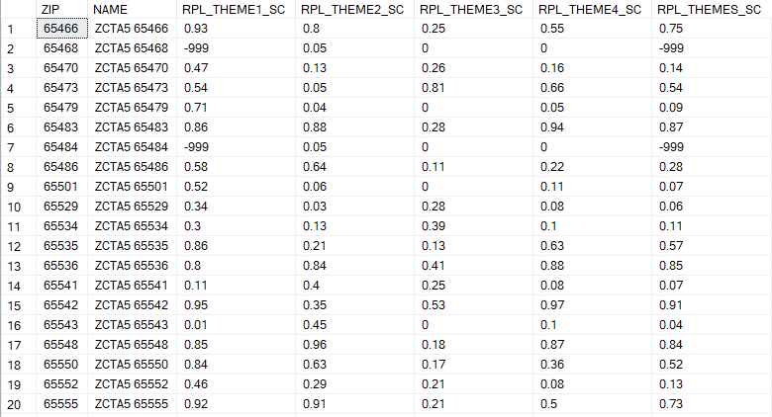

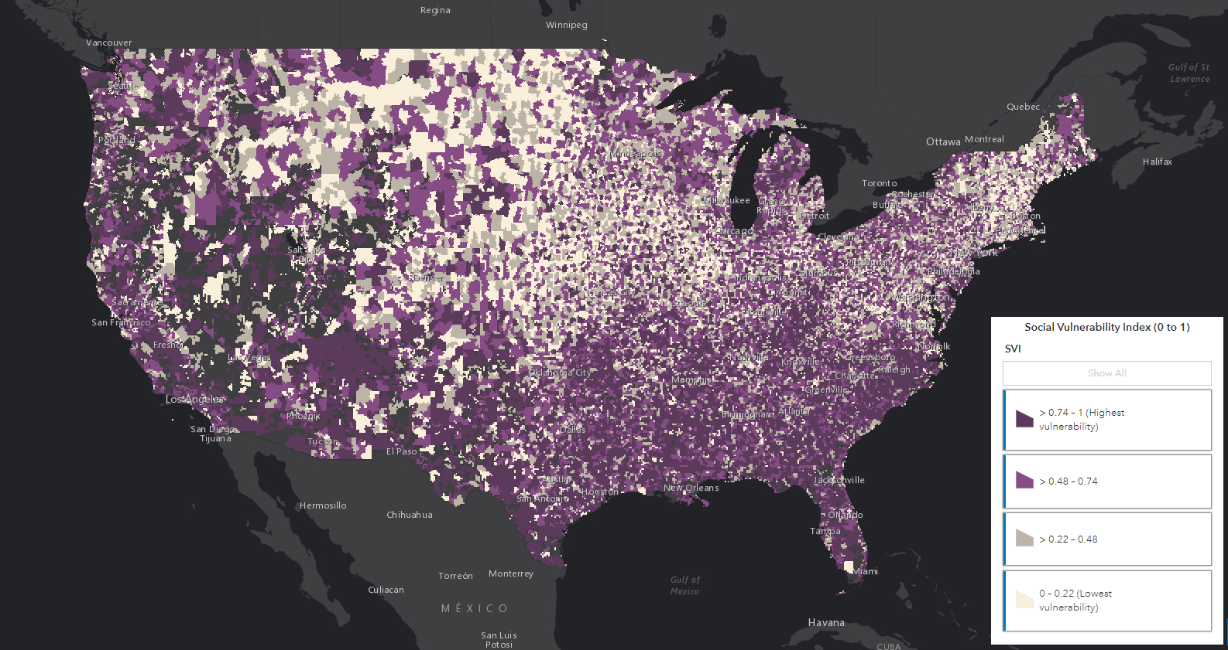

This interactive map provides insight into each of the linked area level datasets above the zip code level across the US.

* **Area Deprivation Index (ADI)**: ADI is a composite measure of 17 variables designed to describe socioeconomic disadvantage based on income, education, household characteristics, and housing. ADI is based on a measure created by the Health Resource & Services Administration and has been refined, adapted, and validated to the Census Block Group. ADI is available at Zip plus 4 and Census tract level. Higher ADI values represent more deprived areas. Below is the information about the 17 core variables, their data type and definitions. ACS has bulk of detail tables and the ACS table ID is purposely numbered to describe its content and format. The ID helps to uniquely identify the table to that variable. ADI_Mean_NATRANK_SC, ADI_Median_NATRANK_SC, ADI_StdErr_NATRANK_SC and ADI_Min_NATRANK_SC are the calculated variables.

|  |  |  |  |  |
| --- | --- | --- | --- | --- |
| **Attribute/Column Name** | **Attribute/Column Physical Name** | **Physical Data Type** | **Definition/Survey Question** | **ACS Table ID** |
| Zip | Zip | varchar(50) | ZIP code |  |
| NAME | NAME | nvarchar(50) | ZCTA5 + ZIP code |  |
| LEDU | Education | nvarchar(50) | % of the population aged 25+ with < 9-year education | (B15002) |
| HEDU | Education | nvarchar(50) | % of the population aged 25+ with at least a high school education | (B15002) |
| IBPL | Poverty | nvarchar(50) | % of the families below poverty level | (B17010) |
| ID | Poverty | float | Income disparity | (B19001) |
| MFI | Poverty | int | Median Family Income | (B19113) |
| ULF | Employment | nvarchar(50) | % of the civilian labor force unemployed (aged 16+) | (B23025) |
| OOH | Housing | nvarchar(50) | % of the owner-occupied housing units | (B25003) |
| PPH | Housing | nvarchar(50) | % of the households with >1 person per room | (B25014) |
| LCPF | Poverty | nvarchar(50) | % of the occupied housing units lacking complete plumbing facilities | (B25043) |
| HWT | Poverty | nvarchar(50) | % of the households without a telephone | (B25043) |
| HWMV | Housing | nvarchar(50) | % of the households without a motor vehicle | (B25044) |
| MGR | Housing | int | Median gross rent | (B25064) |
| MHV | Housing | int | Median home value | (B25077) |
| MMHM | Housing | int | Median monthly mortgage | (B25088) |
| PB150P | Poverty | nvarchar(50) | % of the population below 150% poverty threshold | (C17002) |
| _16YWC | Employment | float | % of the employed person 16+ in a white-collar occupation | (C24010) |
| SPHWC | Poverty | float | % of the single-parent households with dependents <18 | (SF1P20-P02002) |
| ADI_Mean_NATRANK_SC | ADI_Mean_NATRANK_SC | float | The mean ADI national rank score | Calculated Variable |
| ADI_Median_NATRANK_SC | ADI_Median_NATRANK_SC | float | The median of ADI national rank score | Calculated Variable |
| ADI_StdErr_NATRANK_SC | ADI_StdErr_NATRANK_SC | nvarchar(50) | The standard error of national rank score | Calculated Variable |
| ADI_Min_NATRANK_SC | ADI_Min_NATRANK_SC | int | The minimum ADI national rank score | Calculated Variable |
| ADI_Max_NATRANK_SC | ADI_Max_NATRANK_SC | int | The maximum ADI national rank score | Calculated Variable |
| ADI_Range_NATRANK_SC | ADI_Range_NATRANK_SC | nvarchar(50) | The range of ADI national rank score | Calculated Variable |

**The link to access the ADI Index**: <https://www.hipxchange.org/ADI>

**Technical Documentation:** https://dcri.atlassian.net/wiki/spaces/DBIA/pages/2999222409/rpt+adi+ref

Below is an example of how the table will look like once we append all the ACS variables that are used to calculate the ADI_SC variables

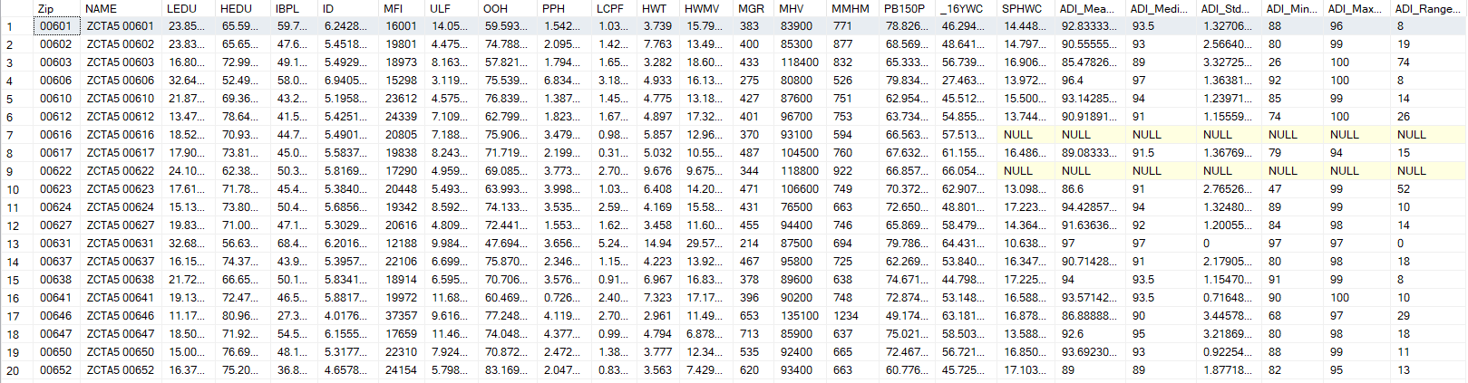

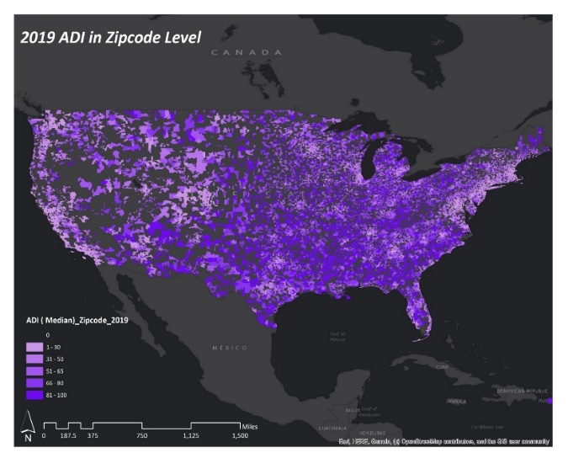

This interactive map provides insight into each of the linked area level datasets above the zip code level across the US.

**Contact Information:** For any variables listed above that do not have guidance or if you have questions about linking them, please contact CDCC (via your EIT or by emailing Vineela Sunkepalli – [Vineela.sunkepalli@duke.edu](mailto:Vineela.sunkepalli@duke.edu)).